# CI Assignment – 3 (kanimozhi KS (311119205010))

# 04-05-2022

**Implementation of Neuro Fuzzy Inference System using Python**

**Aim:**

To implement a Neuro Fuzzy Inference System using Python.

**Test Code:**

import sys import anfis import numpy

import membership.mfDerivs

import membership.membershipfunction

# numpy.loadtxt('c:\\Python_fiddling\\myProject\\MF\\trainingSet.txt',usecols=[1,2,3]) ts = numpy.loadtxt("trainingSet.txt", usecols=[1, 2, 3])

X = ts[:, 0:2]

Y = ts[:, 2]

mf = [[['gaussmf', {'mean': 0., 'sigma': 1.}], ['gaussmf', {'mean': -1., 'sigma': 2.}],

['gaussmf', {'mean': -4., 'sigma': 10.}], ['gaussmf', {'mean': -7., 'sigma': 7.}]],

[['gaussmf', {'mean': 1., 'sigma': 2.}], ['gaussmf', {'mean': 2., 'sigma': 3.}],

['gaussmf', {'mean': -2., 'sigma': 10.}], ['gaussmf', {'mean': -10.5, 'sigma': 5.}]]]

mfc = membership.membershipfunction.MemFuncs(mf) anf = anfis.ANFIS(X, Y, mfc) anf.trainHybridJangOffLine(epochs=20) print(round(anf.consequents[-1][0], 6))

print(round(anf.consequents[-2][0], 6))

print(round(anf.fittedValues[9][0], 6))

if round(anf.consequents[-1][0], 6) == -5.275538 and round(anf.consequents[-2][0], 6) ==

-1.990703 and round(anf.fittedValues[9][0], 6) == 0.002249: print('test is good')

print("Plotting errors") anf.plotErrors() print("Plotting results") anf.plotResults()

**Output**

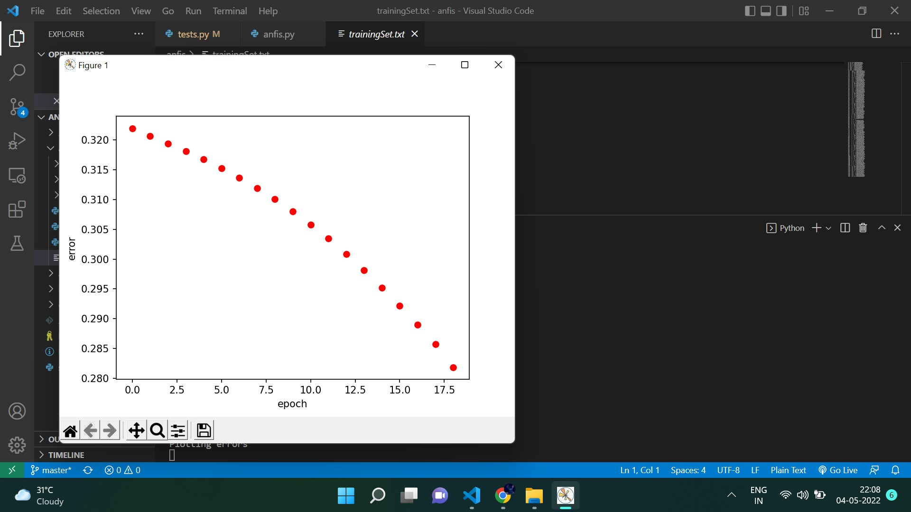

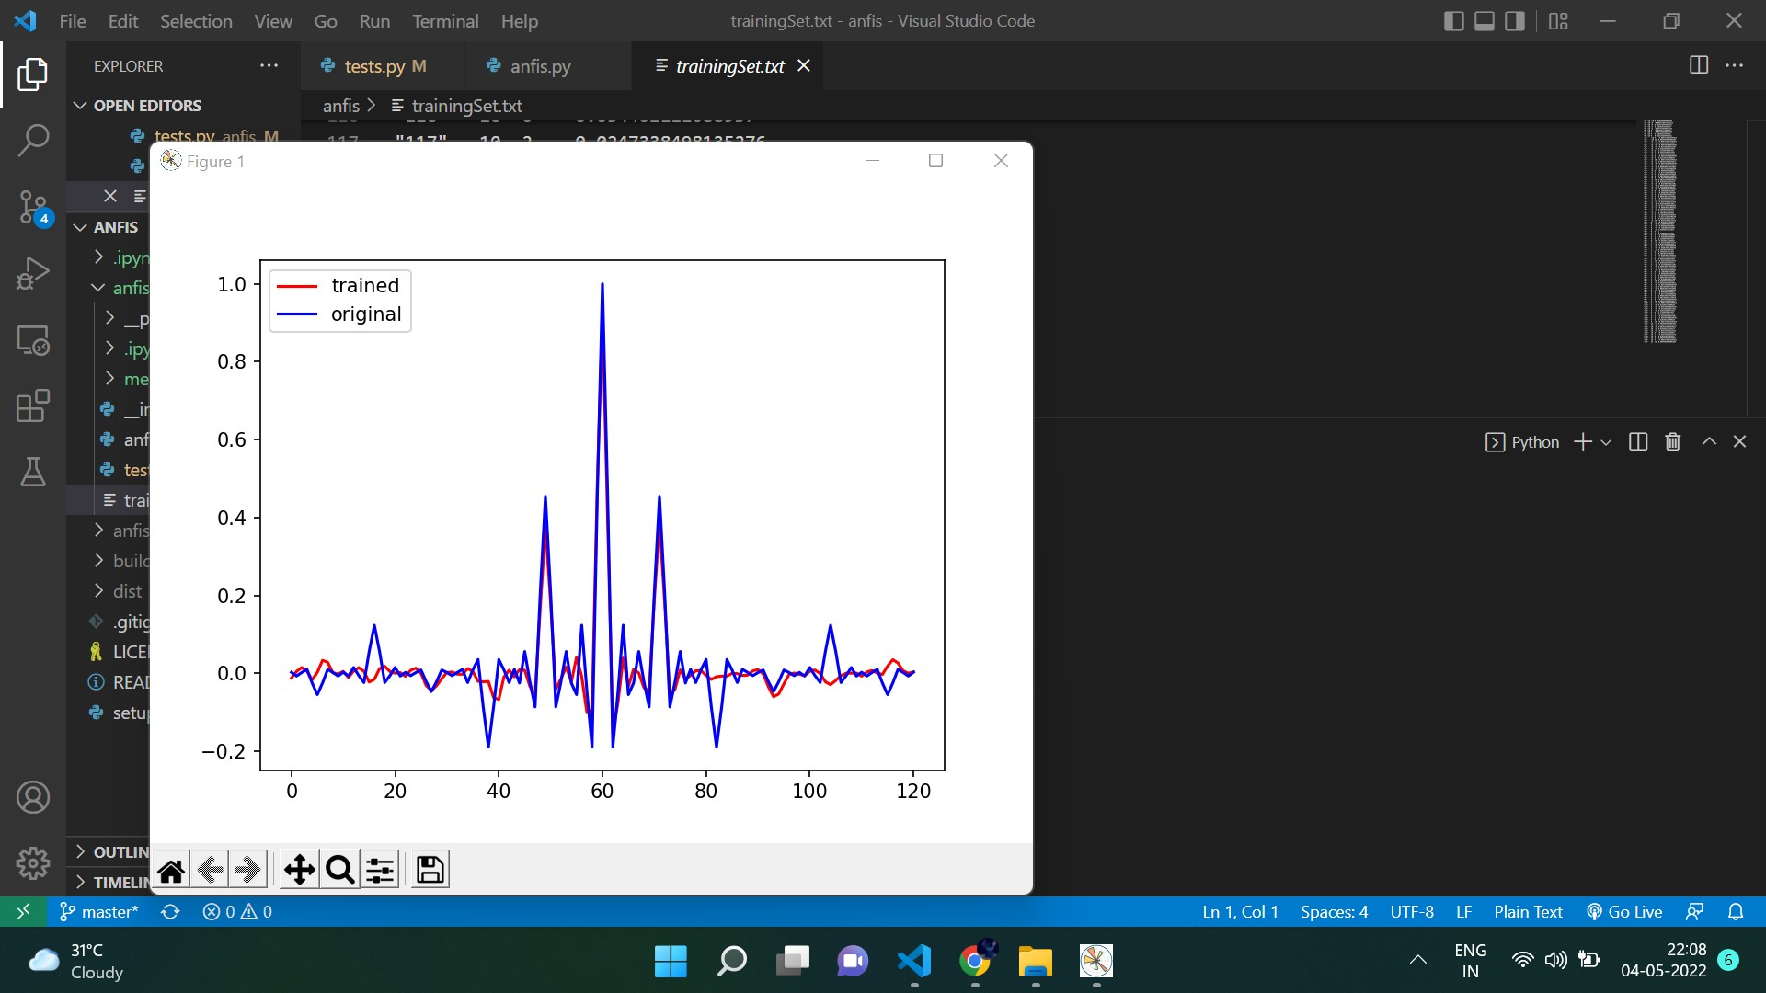

**Result**

Thus the Neuro Fuzzy Inference System has been implemented using Python.